Rotary Club of Kathmandu Mid-Town
Breakfast Chatter




25 November 2011 The Weekly Bulletin of Rotary Club of Kathmandu Mid-Town Bc-11.25/011-12

District: 3292 Web: www.rotarymidtown.org.np Club Id : 26776

NOVEMBER IS THE ROTARY FOUNDATION MONTH
In anticipation of The Rotary Foundation’s 100-year anniversary in 2017, the RF Trustees developed the Future Vision Plan to move the Foundation toward its second century of service. The plan was designed to reflect the desires and interests of Rotarians worldwide to give the Foundation a more sustainable and visible impact in the world. The new model is simple, flexible, and supported with online systems.
The Future Vision Plan is designed to:
• Simplify Foundation programs and processes consistent with the mission;
• Focus Rotarian service efforts where they will have the greatest impact by addressing priority world needs that are relevant to Rotarians;
• Offer funding options to help achieve both global and local goals;
• Increase the sense of ownership at the district and club levels by transferring more decisions to the districts;
• Advance understanding of the Foundation’s work and enhance Rotary’s public image.

What is your vision for a better world?
The Rotary Foundation enables Rotarians to advance world understanding, goodwill, and peace through the improvement of health, the support of education, and the alleviation of poverty.

Friday, 18 November:
23rd Charter Day Celebration
at Dhaba Restaurant, Thapathali
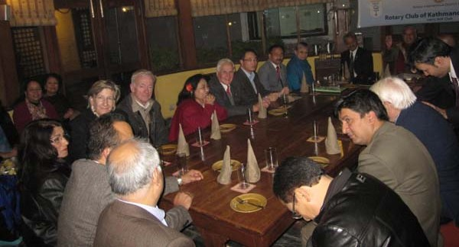
Regular weekly meeting of the Club was held as a part of Charter Night Celebration

Induction of New Member:
Mr Paras SJB Rana was inducted as a new member of the Club during the Charter Night Celebration.
After induction Paras Rana was declared as the newest Rotarian of Rotary International world.
Rotarian Paras was congratulated by President Som and other members of the Club.
And he was welcomed into the Club with a big round of applause.
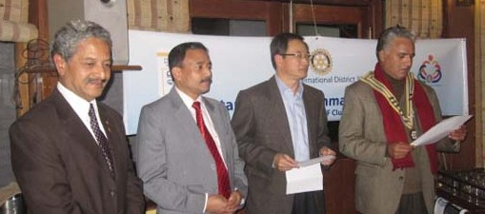
PP William conducting induction.
Seen in the picture are IPP Pratap, new member Paras, PP William and President Som
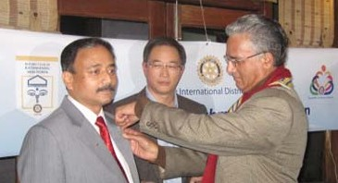
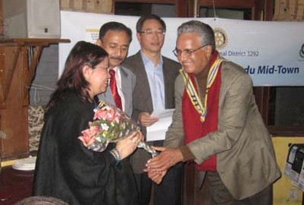
President Som providing Rotary pin to Paras
President Som welcoming Paras's spouse Nita with a flower bouquet

Weekly Meetings and Programs :
Date | Program/Speaker | Program/Topics of Presentation
25 November 2011 | 2nd Club Assembly | 2nd Club Assembly
2 December 2011 | Dr Donald Sammut | Plastic/ Hand Surgery Experiences
9 December 2011 | DG Visit | District Governor visiting the Club
16 December 2011 | ?

25 November, Friday:
2nd Club Assembly

The Committee chairs/Treasurer will be submitting activity/service project report of their respective avenues at the Club assembly for information and/or discussion.

Eye Bling!
Dr Chandrashekhar Chawan of Mumbai, India
created a line of luxury contact lenses embedded with gold and diamonds!
Source: The Rising Nepal

Giving New Meaning to "Service ABOVE Self":
Rotarian John Chambers, President, Rotary Club of Detroit AM, surprised the Rotary Club of Detroit with a special presentation at their June 15 meeting. Over a year in the planning, and thanks to John's persistence, the centennial banner of the Detroit Rotary Club was flown on STS-133 earlier this year. The certificate reads: "This United States flag, crew patch and accompanying Detroit Rotary Club banner were flown to the International Space Station aboard the 39th and Final Flight of the Space Shuttle Discovery during STS-133, February 24 - March 9, 2011, traveling 5.3 million miles in 202 orbits of the Earth. Presented to Detroit Rotary Club, Celebrating 100 Years of Service Above Self, from the National Aeronautics and Space Administration.
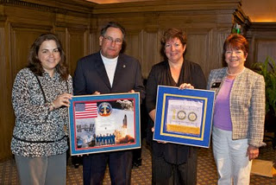

Pictured are Lisa Verona, of Senator Carl Levin's office, Detroit AM President John Chambers,
Detroit President Mary Anne Demo, and District Governor Kim Towar.

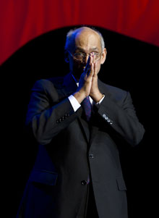
In order to achieve anything in this world, a person has to use all the resources he can draw
on. And the only place to start is with ourselves and within ourselves. The questions we
need to ask ourselves are: Why am I here? It is because we all seek a sense of fulfillment
in life, and the responsibilities we are about to take up are a part of that fulfillment.
RI President Kalyan Banerjee

Life with computers:


Please send project/activity information, suggestions and photos etc to :
BC Editor: RR Shrestha email: rryes@wlink.com.np

25 November 2011 The Weekly Bulletin of Rotary Club of Kathmandu Mid-Town bc-11.25/011-12

